**Mogelijke landschappen**

[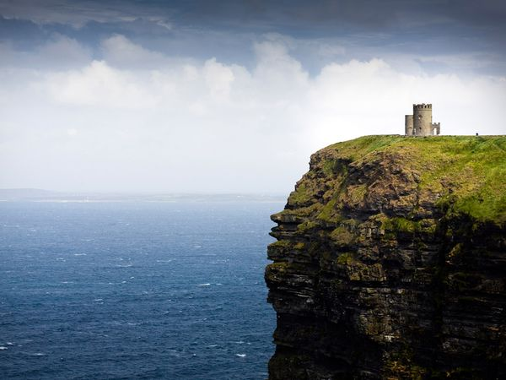](http://www.google.be/url?sa=i&rct=j&q=&esrc=s&frm=1&source=images&cd=&cad=rja&docid=azqiBs5NlfKTgM&tbnid=t52KA_oPEq_UPM:&ved=0CAUQjRw&url=http://travel.nationalgeographic.com/travel/countries/ireland-guide/&ei=4NcoUY3aFuLB0QXJlYGgCA&bvm=bv.42768644,d.d2k&psig=AFQjCNEoWszZu-Q6WyyfM_jnM9lGk9xUlA&ust=1361717585377679) [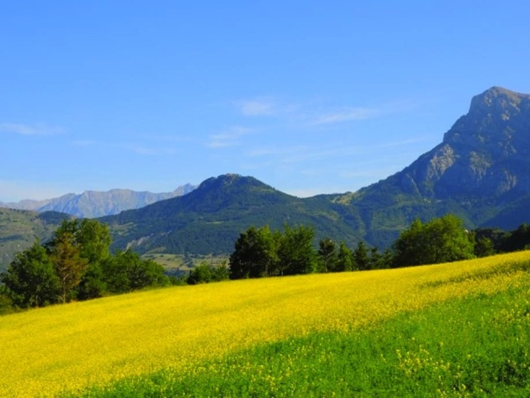](http://www.google.be/url?sa=i&rct=j&q=&esrc=s&frm=1&source=images&cd=&cad=rja&docid=L_FmbUs9sm-xzM&tbnid=mdA2prEGHjABQM:&ved=0CAUQjRw&url=http://www.geo.fr/voyages/vos-voyages-de-reve/hautes-alpes-randonnee-autour-de-breziers/paysage-verdoyant&ei=HtooUcbYGuqa1AW434HQBw&bvm=bv.42768644,d.d2k&psig=AFQjCNE7wlGrLznXXUXES9k2YDzTlNrPqA&ust=1361717953720972)

[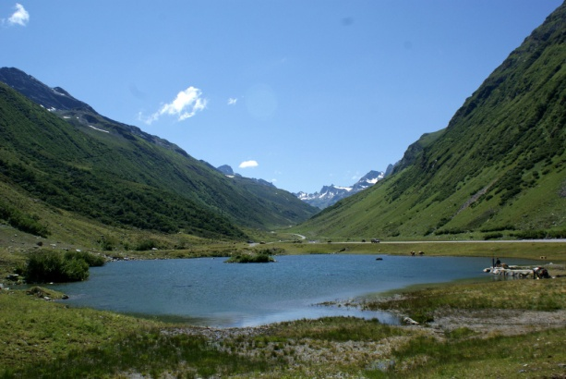](http://www.google.be/url?sa=i&rct=j&q=&esrc=s&frm=1&source=images&cd=&cad=rja&docid=e6TrXus5kcPrAM&tbnid=dbtjYT9KL90HTM:&ved=0CAUQjRw&url=http://instantcomplice.canalblog.com/archives/2012/09/02/25016795.html&ei=XdkoUb6wHauX0QXq44CwDQ&bvm=bv.42768644,d.d2k&psig=AFQjCNE7wlGrLznXXUXES9k2YDzTlNrPqA&ust=1361717953720972) 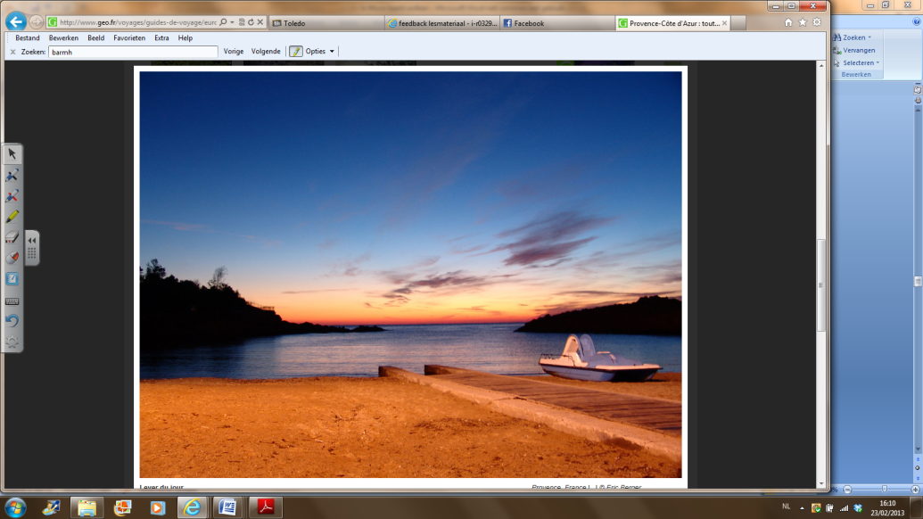

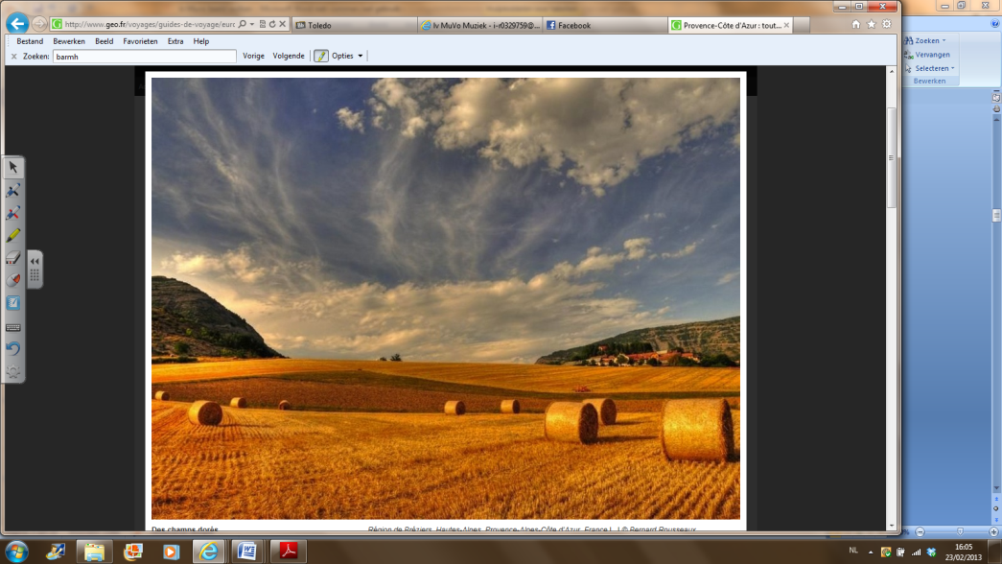 [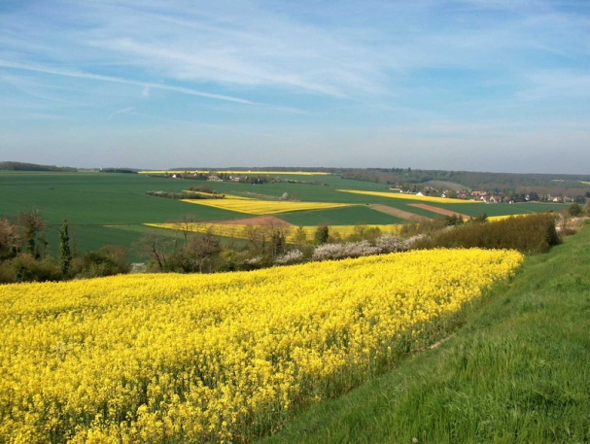](http://www.google.be/url?sa=i&rct=j&q=&esrc=s&frm=1&source=images&cd=&cad=rja&docid=g1FMISfMVdy8YM&tbnid=6K8jaIE0m_3QDM:&ved=0CAUQjRw&url=http://www.all-free-photos.com/show/showphoto.php?idph=IM2595&lang=fr&ei=Yi8tUa6sEaqV0QXCk4GABA&bvm=bv.42965579,d.d2k&psig=AFQjCNHYajtdGO_vad3B4ftNea-PGvsA9g&ust=1362002142531172)

[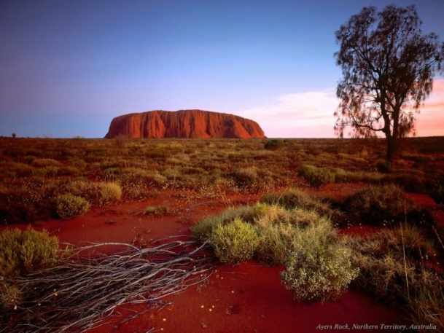](http://www.google.be/url?sa=i&source=images&cd=&cad=rja&docid=b3kjDeW8TC7k5M&tbnid=_yzN8sAhvUNOvM:&ved=0CAgQjRwwAA&url=http://huur-camper.nl/australie/&ei=2i4tUfi7PO-k0AWd0IDYDA&psig=AFQjCNH2WJJti6GVj1ZftAXs3G-qfPrxdg&ust=1362002011063539) 