**Inspiratiefiguren Magritte**

[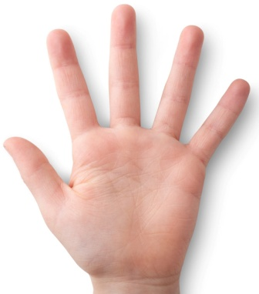](http://www.google.be/url?sa=i&rct=j&q=&esrc=s&frm=1&source=images&cd=&cad=rja&docid=AmdcRrhmTuepoM&tbnid=EKEEDSBGbC1ZxM:&ved=0CAUQjRw&url=http://www.ucl.ac.uk/news/news-articles/1006/10061602&ei=5CYtUeY87crQBdOUgNgK&bvm=bv.42965579,d.d2k&psig=AFQjCNGXiRz93EyG3uEtKZM3CYZIIGpUDA&ust=1361999964148642) [](http://www.google.be/url?sa=i&rct=j&q=&esrc=s&frm=1&source=images&cd=&cad=rja&docid=Jmd5CSHAeJEHPM&tbnid=HXdK8bKkkEd0ZM:&ved=0CAUQjRw&url=http://www.klein-sinaai.be/tourisme/fietsroutes/247-nieuwe-fietskaart-klavertje-vier&ei=-yYtUZ-MGMm90QWB0ICIBg&bvm=bv.42965579,d.d2k&psig=AFQjCNGyvH8rWxKL4FaMReccnRSVf1befw&ust=1361999993941397) [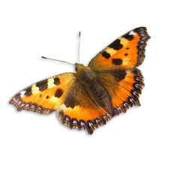](http://www.google.be/url?sa=i&rct=j&q=&esrc=s&frm=1&source=images&cd=&cad=rja&docid=m912Fz5gkiZAjM&tbnid=YlB_R51FmLAZ4M:&ved=0CAUQjRw&url=http://afbeeldingen.wordpress.com/category/vlinder-butterfly/&ei=HCctUe7QIKSa1AXA44GgBw&bvm=bv.42965579,d.d2k&psig=AFQjCNELhlV05WBMzPwuFPdB_uTmBs5Jfw&ust=1362000019983326)

[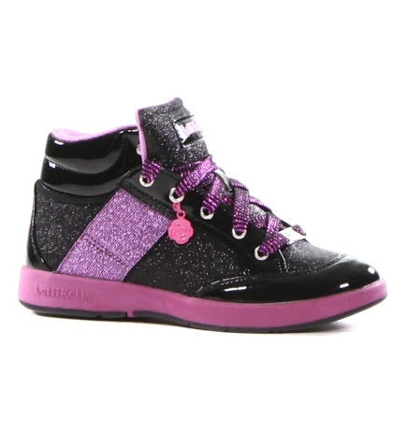](http://www.google.be/url?sa=i&rct=j&q=&esrc=s&frm=1&source=images&cd=&cad=rja&docid=5us7mOM03TDidM&tbnid=SW5X8_Bh3CYz2M:&ved=0CAUQjRw&url=http://www.torfs.be/lelli-kelly-zwarte-schoen-120706&ei=lyctUcG2CubB0QWhpYGQDw&bvm=bv.42965579,d.d2k&psig=AFQjCNELHwTPO2DJ_l_nuiuq00kH4J8OBQ&ust=1362000144703749) [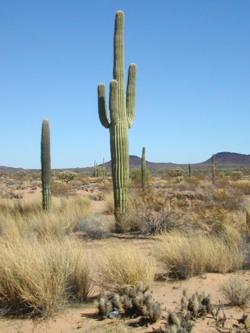](http://www.google.be/url?sa=i&rct=j&q=&esrc=s&frm=1&source=images&cd=&cad=rja&docid=wKIvQD8TYB2x7M&tbnid=JZYwoMH7imdfqM:&ved=0CAUQjRw&url=http://motherscribe.blogspot.com/2011/04/survived-on-cactus-juice-and-their.html&ei=uistUZmWIqXW0QWuzYHYBw&bvm=bv.42965579,d.d2k&psig=AFQjCNEOW4Qva7sTV4J8sDFAaE4TvjN3lw&ust=1362001189747890) [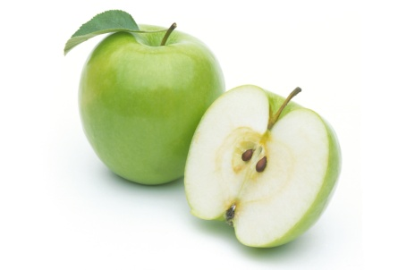](http://www.google.be/url?sa=i&rct=j&q=&esrc=s&frm=1&source=images&cd=&cad=rja&docid=8JtaO325afi_4M&tbnid=R3V-SdsYxcMm5M:&ved=0CAUQjRw&url=http://ons1stekleuterklasje.blogspot.com/2013/01/thema-mmm-lekker-fruit.html&ei=YistUdXeO-iV0QWd9YCoCQ&bvm=bv.42965579,d.d2k&psig=AFQjCNEzZLi_672PJvs3VX5f_XycP19ojQ&ust=1362001114409142)

[](http://2.bp.blogspot.com/-8L6C0Tkf20I/Ta8nTaE4ZQI/AAAAAAAAAAc/uaUUABLVJsk/s1600/moustache-1.jpg) [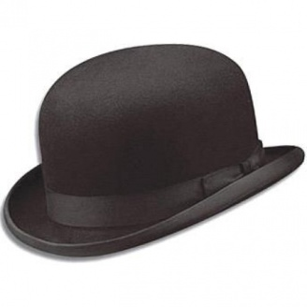](http://www.google.be/url?sa=i&rct=j&q=&esrc=s&frm=1&source=images&cd=&cad=rja&docid=L4yHGoVDXcBxFM&tbnid=FJceTU9SlcXRTM:&ved=0CAUQjRw&url=http://roodnoot.blogspot.com/2011_09_01_archive.html&ei=4CstUeHeHcqp0AXqjIGwCA&bvm=bv.42965579,d.d2k&psig=AFQjCNHXgdBrodSfwzOJiLdPWh1S4z3aFg&ust=1362001245894932) [](http://www.google.be/url?sa=i&rct=j&q=&esrc=s&frm=1&source=images&cd=&cad=rja&docid=bpvqNHAhs_9GcM&tbnid=-BQruygNJ9_dfM:&ved=0CAUQjRw&url=http://denoudenwingerd.com/wijn_glas.html&ei=pCotUd7AOIqe0QWT3YCQBw&bvm=bv.42965579,d.d2k&psig=AFQjCNGyRXoK6swiacFt0gh_UpgQ994Iaw&ust=1362000930906623)

[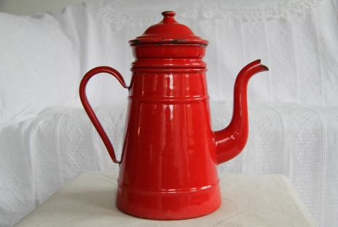](http://www.google.be/url?sa=i&rct=j&q=&esrc=s&frm=1&source=images&cd=&cad=rja&docid=LZbC5S3uIiLhvM&tbnid=30PhQhcMYQJJDM:&ved=0CAUQjRw&url=http://www.deprinsesendekikker.nl/index.php?page=brocante&itempage=9&ei=pwIuUaGSGMbR0QWH8YB4&bvm=bv.42965579,d.d2k&psig=AFQjCNG15N_0aziuZYaXgIOrYR58flbAWw&ust=1362056219077169)[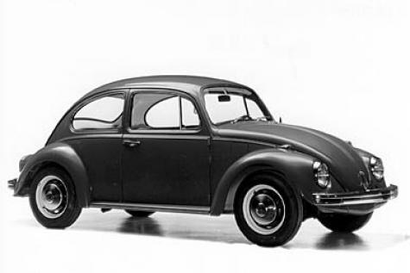](http://www.google.be/url?sa=i&rct=j&q=&esrc=s&frm=1&source=images&cd=&cad=rja&docid=8S4v8aT2shfJPM&tbnid=o8ULs0zbTPapWM:&ved=0CAUQjRw&url=http://bugman.nl/kever-modellen&ei=OAMuUaG2BYqX1AWj4IHQCg&bvm=bv.42965579,d.d2k&psig=AFQjCNHjOKMzPpuls4lnWHX0qhXcezHt7g&ust=1362056370582038)[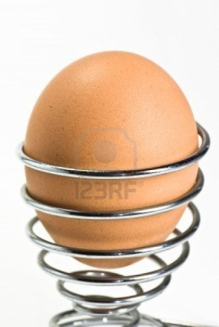](http://www.google.be/url?sa=i&rct=j&q=&esrc=s&frm=1&source=images&cd=&cad=rja&docid=tVNmDBk-nidVRM&tbnid=W0IqttNw4TBCtM:&ved=0CAUQjRw&url=http://nl.123rf.com/photo_4869062_ei-op-metaal-eierdopje-op-witte-achtergrond.html&ei=mQQuUb2WFOec0QWxx4HAAQ&bvm=bv.42965579,d.d2k&psig=AFQjCNHbkOuTZ9vNo6OK8pE4Yy3KLd9ApQ&ust=1362056698685520)