[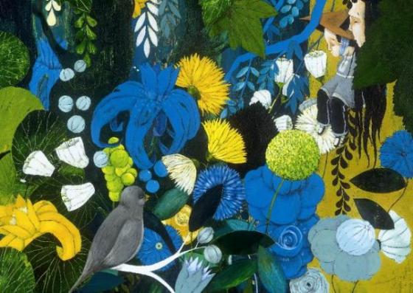](http://www.google.be/url?sa=i&source=images&cd=&cad=rja&docid=iy6YpJxAQWzPpM&tbnid=BvYHI_e4tPdDmM:&ved=0CAgQjRwwAA&url=http://nrcboeken.vorige.nrc.nl/nieuws/woutertje-pieterse-prijs-voor-peter-verhelst-en-carll-cneut&ei=Lku2UfHBEuHG0QX45oHAAw&psig=AFQjCNFxSTLphT0_fFg2vgggFmREXTWhuQ&ust=1370987694349237)

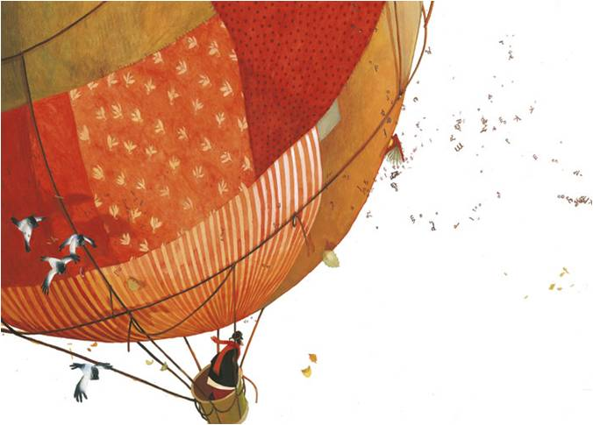

[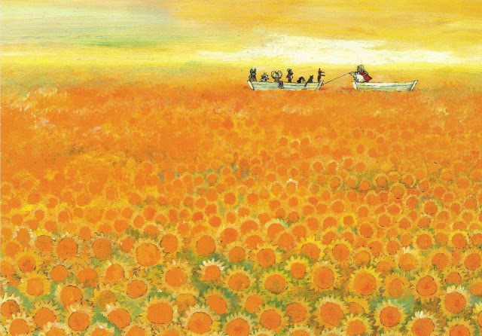](http://www.google.be/url?sa=i&rct=j&q=&esrc=s&frm=1&source=images&cd=&cad=rja&docid=SXReFPDj8TcXtM&tbnid=JEdeJT7_a9guRM:&ved=0CAUQjRw&url=http://www.123people.com/s/marit+t%C3%B6rnqvist&ei=n022UfzOE6mq0QWgvIGwCw&bvm=bv.47534661,d.d2k&psig=AFQjCNF9sq_XJFbDcn-QenYSKlVSEKxUlA&ust=1370988307558725)[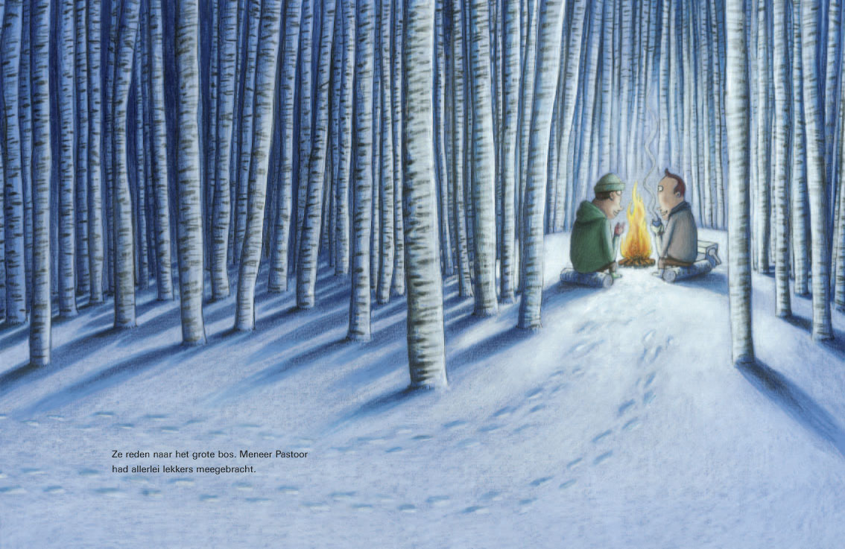](http://www.google.be/url?sa=i&rct=j&q=&esrc=s&frm=1&source=images&cd=&cad=rja&docid=90kLQJbA6LGDeM&tbnid=yRS77RNpCYJpEM:&ved=0CAUQjRw&url=http://www.vreemdevogels.be/klaas-stap-voor-stap/&ei=EEy2UbraEKfL0AW8zYCgAw&bvm=bv.47534661,d.d2k&psig=AFQjCNEFHjmypzG-SUR12XZz062KP6y9Og&ust=1370987913674957)

[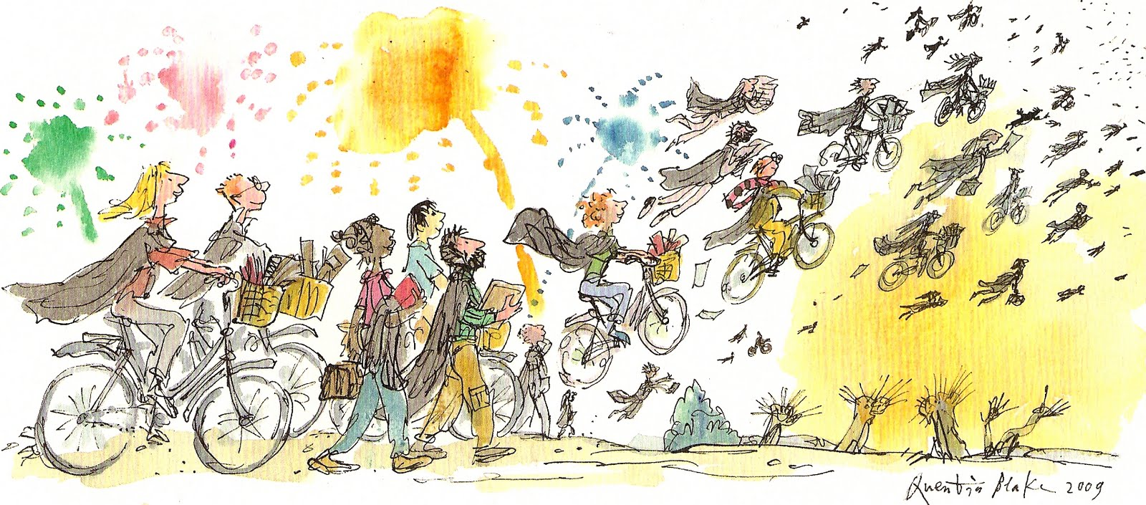](http://www.google.be/url?sa=i&rct=j&q=&esrc=s&frm=1&source=images&cd=&cad=rja&docid=maoAXYk_C3sasM&tbnid=81bAWE6RNHpI5M:&ved=0CAUQjRw&url=http://meldonc.blogspot.com/2011/06/bicycles.html&ei=_Ey2UdSANebI0QWpkYCIAg&bvm=bv.47534661,d.d2k&psig=AFQjCNH78pAH0e-pxWzfWn4olKDE14pSpw&ust=1370988103935879)

[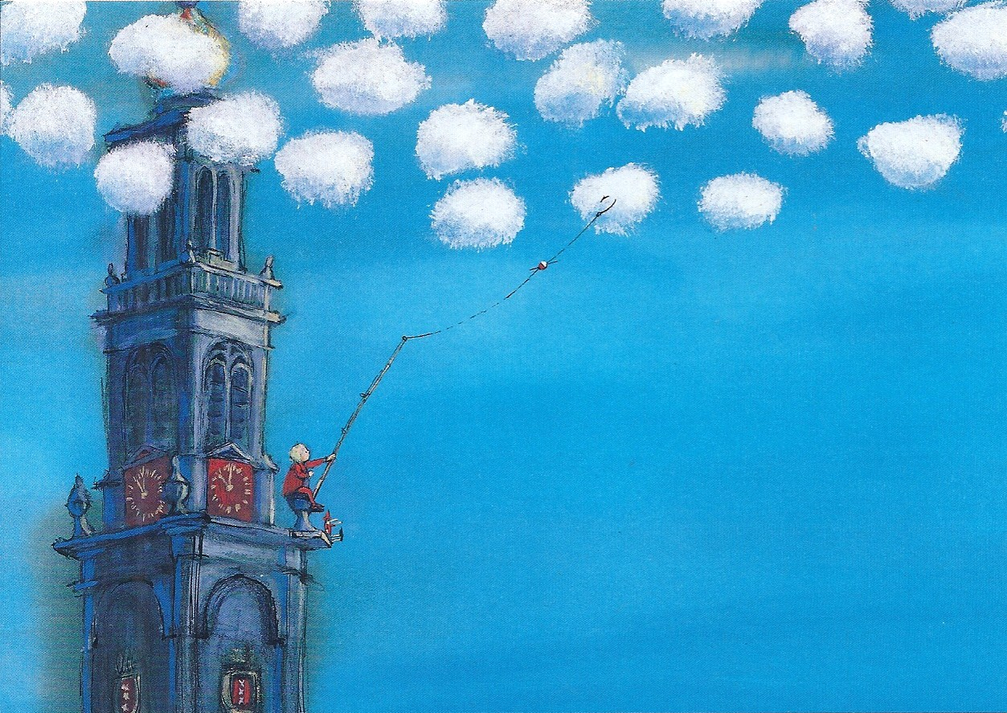](http://www.google.be/url?sa=i&rct=j&q=&esrc=s&frm=1&source=images&cd=&cad=rja&docid=DiiBq1czJVz87M&tbnid=PiL32-BqQEZo1M:&ved=0CAUQjRw&url=http://nogmeerpost.blogspot.com/2012/10/out-to-netherlands_21.html&ei=wU22UeLxDsyp0AW2g4GwBw&bvm=bv.47534661,d.d2k&psig=AFQjCNF9sq_XJFbDcn-QenYSKlVSEKxUlA&ust=1370988307558725)

[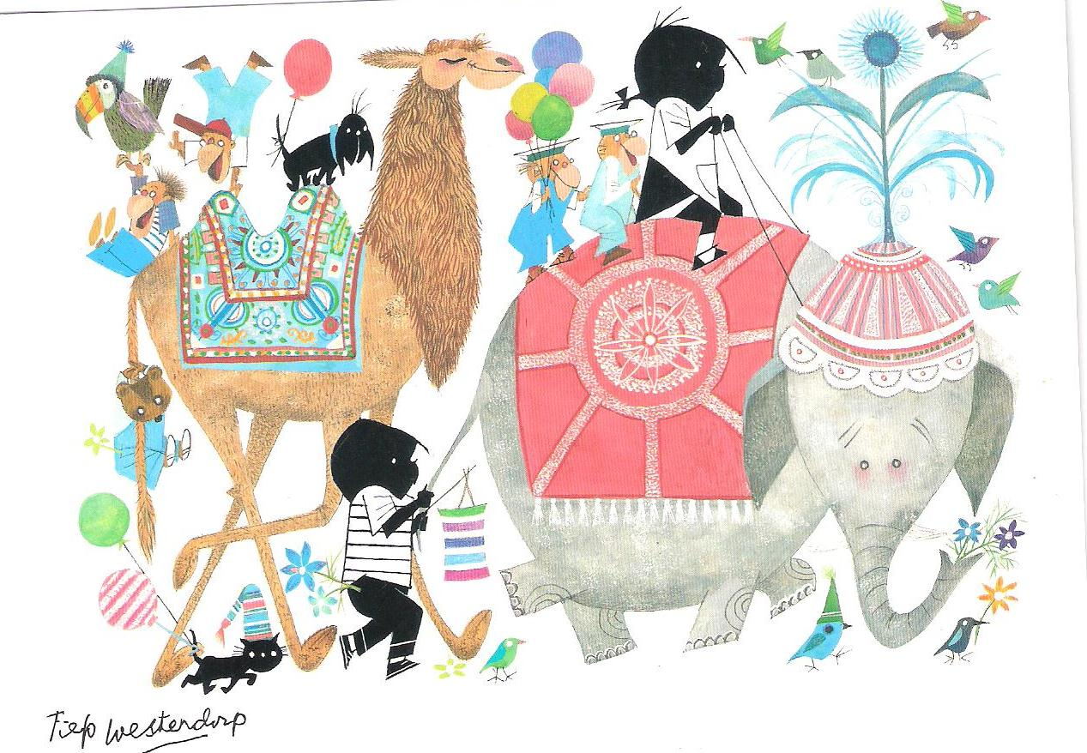](http://www.google.be/url?sa=i&rct=j&q=fiep+westendorp&source=images&cd=&cad=rja&docid=8BqDHXSJGjYcuM&tbnid=LeS-gEF3W0iIWM:&ved=0CAUQjRw&url=http://michellegross.blog.com/2011/05/18/1-jip-and-janneke/&ei=w062UaCtHIml0QW4h4GgBQ&bvm=bv.47534661,d.d2k&psig=AFQjCNGsd_b_4zWPUuEUVek3ECqHlRXknQ&ust=1370988596970478)

[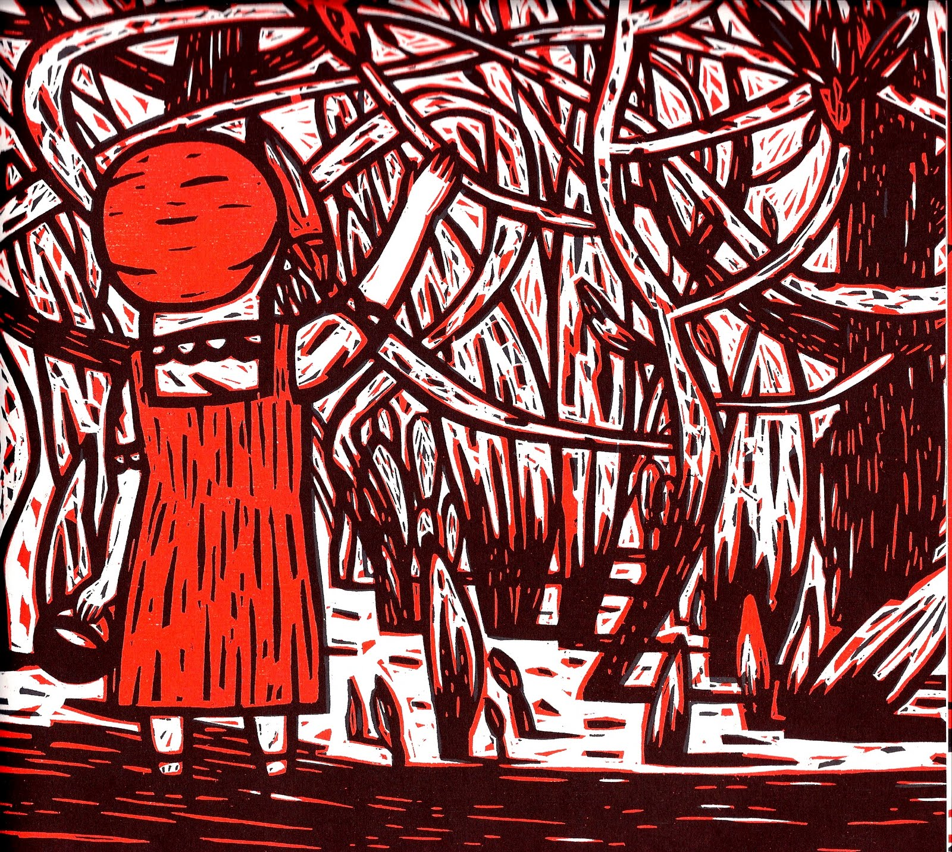](http://www.google.be/url?sa=i&source=images&cd=&cad=rja&docid=JLeq281AQVkDdM&tbnid=f9MQLNPzKlqXVM:&ved=0CAgQjRwwAA&url=http://mattbrayillustration.blogspot.com/2010/06/isabelle-vandenabeele.html&ei=Jk62UeKcMsmq0QWE2ICQDg&psig=AFQjCNH0fmwP9vBNJmpwaJsoFEmjUcX57g&ust=1370988454856167)

[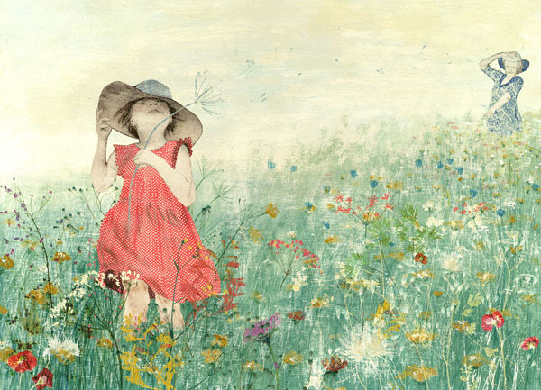](http://www.google.be/url?sa=i&rct=j&q=kaatje+vermeire&source=images&cd=&cad=rja&docid=SNCGdtlAymzciM&tbnid=xoo0f_uw7OLkpM:&ved=0CAUQjRw&url=http://www.kaatjevermeire.be/&ei=6VC2UdqiJKKk0QXOnYGoBg&bvm=bv.47534661,d.d2k&psig=AFQjCNEuypNaOAn8o8eVLaSC6p9qPLk6dA&ust=1370989158490591)[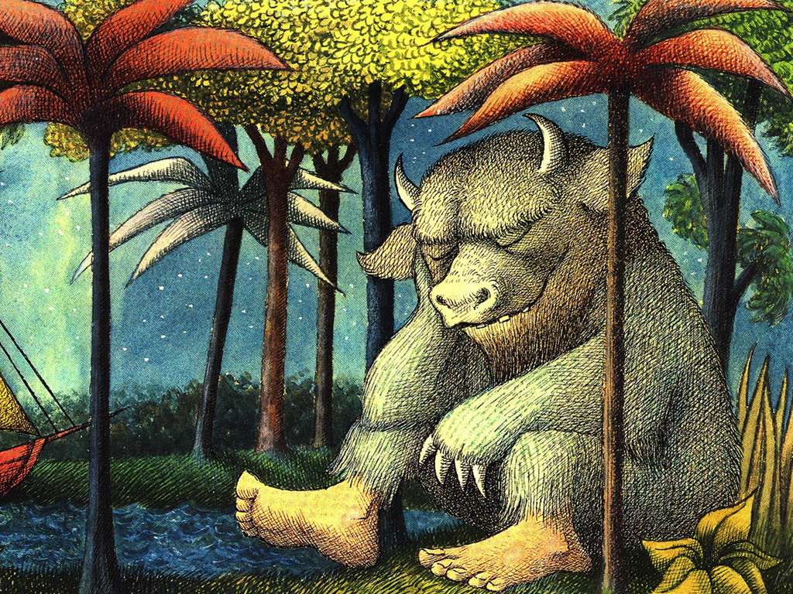](http://rkdfind.tumblr.com/post/22676430858)

[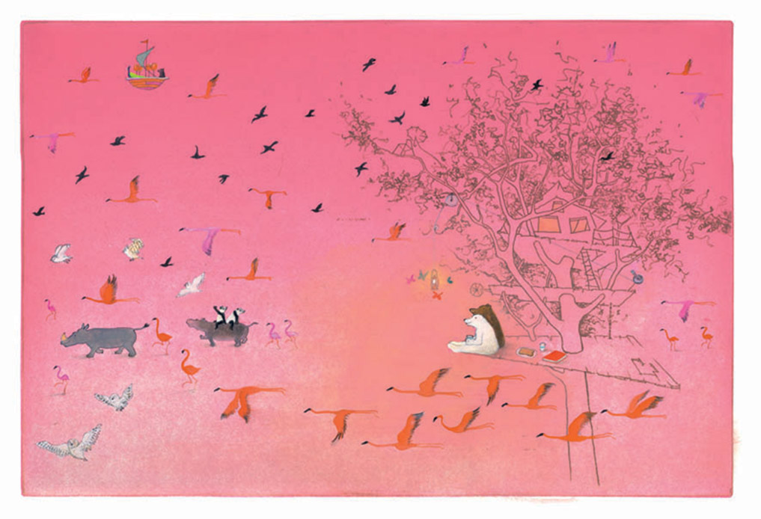](http://www.google.be/url?sa=i&rct=j&q=&esrc=s&frm=1&source=images&cd=&cad=rja&docid=u9JYfZjB8DyKUM&tbnid=TUhl453UC9q_pM:&ved=0CAUQjRw&url=http://itsmeleonie.blogspot.com/2010/12/heee-vandaag-heb-ik-mijn-verjaardag.html&ei=k1G2UfX2Dq-X0AXFzYHwBg&bvm=bv.47534661,d.d2k&psig=AFQjCNFyu5T2qeLzOMySuwWhV5kSgCv1vg&ust=1370989327982582)

[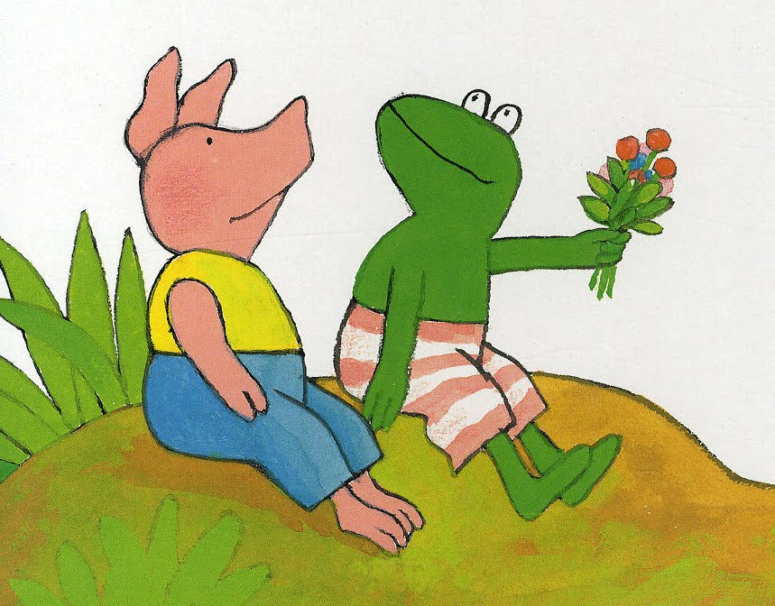](http://www.google.be/url?sa=i&rct=j&q=&esrc=s&frm=1&source=images&cd=&cad=rja&docid=BM0Ouxvz2xfLkM&tbnid=dsxuxlfkaLwmUM:&ved=0CAUQjRw&url=http://elayah.blogspot.com/2011/04/1-april-kikker-in-je-bil.html&ei=5lG2Uaj5DqO40QX6y4HIBg&bvm=bv.47534661,d.d2k&psig=AFQjCNEDxBgSGvEO71JNbz61fC1Xjyjsnw&ust=1370989384648339)[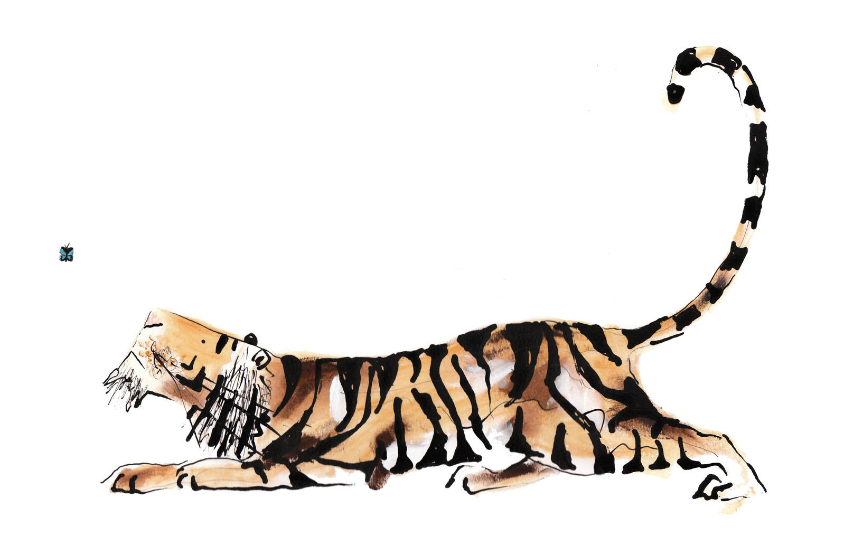](http://www.google.be/url?sa=i&rct=j&q=&esrc=s&frm=1&source=images&cd=&cad=rja&docid=ur3trlPthMqBNM&tbnid=iJQuKPbN7D69TM:&ved=0CAUQjRw&url=http://aestheticbookblog.blogspot.com/2011/02/illustrations-of-catherine-rayner.html&ei=DFO2UbOjD9PK0AW-l4HoBQ&bvm=bv.47534661,d.d2k&psig=AFQjCNHUxPBZwOaImNwDjsf_RCR0qW8jUA&ust=1370989677192285) [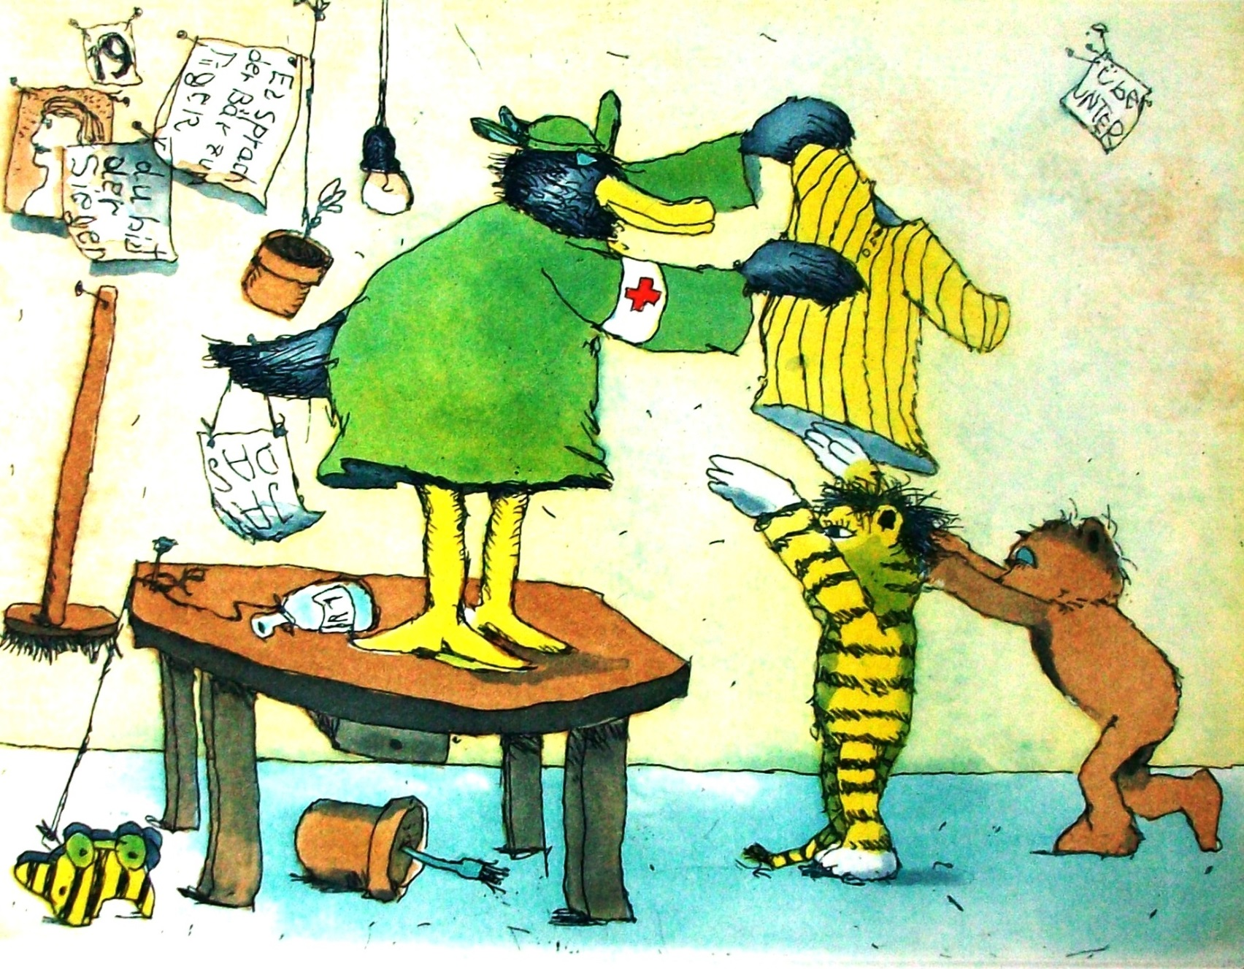](http://www.google.be/url?sa=i&rct=j&q=&esrc=s&frm=1&source=images&cd=&cad=rja&docid=9MXgSydI6zjZ_M&tbnid=bflwbQZS0-3JKM:&ved=0CAUQjRw&url=http://www.janosch-ausstellung.de/epages/62047002.sf/de_DE/?ObjectPath=/Shops/62047002/Products/JAN-AM-49-1JA&ei=UFK2UduCH4SZ0QWmhIDoDg&bvm=bv.47534661,d.d2k&psig=AFQjCNH8M-mzQ0jZ2yETEDdreVugV00i-A&ust=1370989502557611)

[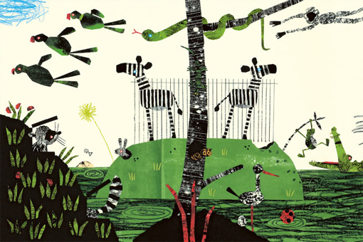](http://www.google.be/url?sa=i&rct=j&q=&esrc=s&frm=1&source=images&cd=&cad=rja&docid=RoSO_pCN3cCENM&tbnid=clk-RULOXldRhM:&ved=0CAUQjRw&url=http://palatinka.blogspot.com/2012/10/fleur-van-der-weel.html&ei=z1O2Uc-zNuWm0AWO1YG4Ag&bvm=bv.47534661,d.d2k&psig=AFQjCNFD0GGIQGwneQ9-ub-doq4a2BMh2w&ust=1370989888702393)