[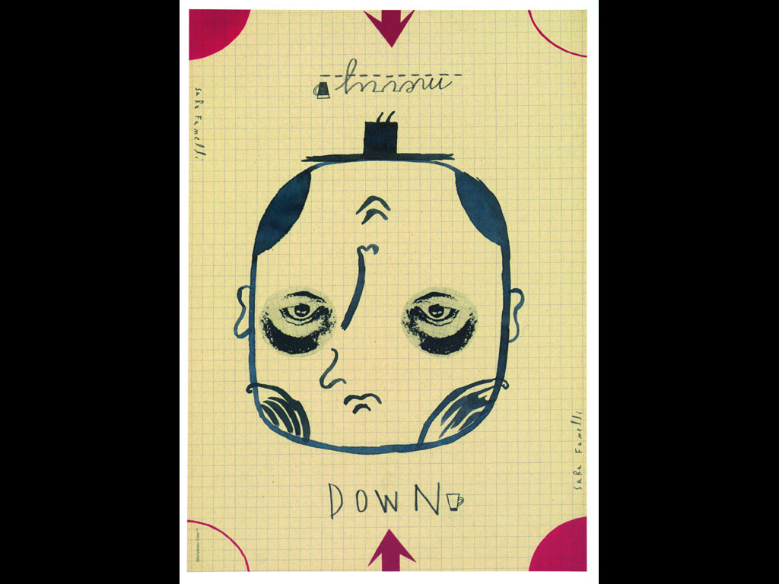](http://www.google.be/url?sa=i&rct=j&q=&esrc=s&frm=1&source=images&cd=&cad=rja&docid=wxMGwb9muIDDNM&tbnid=0-VnFInaRaR5jM:&ved=0CAUQjRw&url=http://www.adforum.com/creative-work/ad/player/28977&ei=rlKZUYu5J7Ga0AXhk4DoBQ&bvm=bv.46751780,d.bGE&psig=AFQjCNEZC5NeiQY5O0dhFMxgaB_fXQP5ow&ust=1369089060867975)

[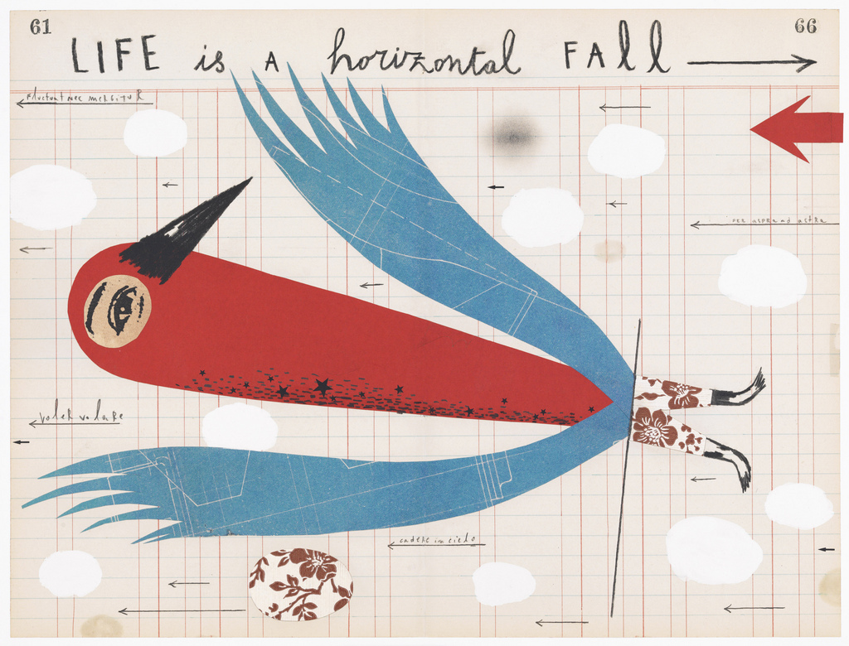](http://www.google.be/url?sa=i&rct=j&q=&esrc=s&frm=1&source=images&cd=&cad=rja&docid=pHeLBs5vDcnt1M&tbnid=MD1rtlgSGIgaEM:&ved=0CAUQjRw&url=http://www.designlondonblog.co.uk/2011/07/sara-fanelli-at-tate-shop.html&ei=4lKZUe6NGIqw0AXDh4HoCw&bvm=bv.46751780,d.bGE&psig=AFQjCNEZC5NeiQY5O0dhFMxgaB_fXQP5ow&ust=1369089060867975)

[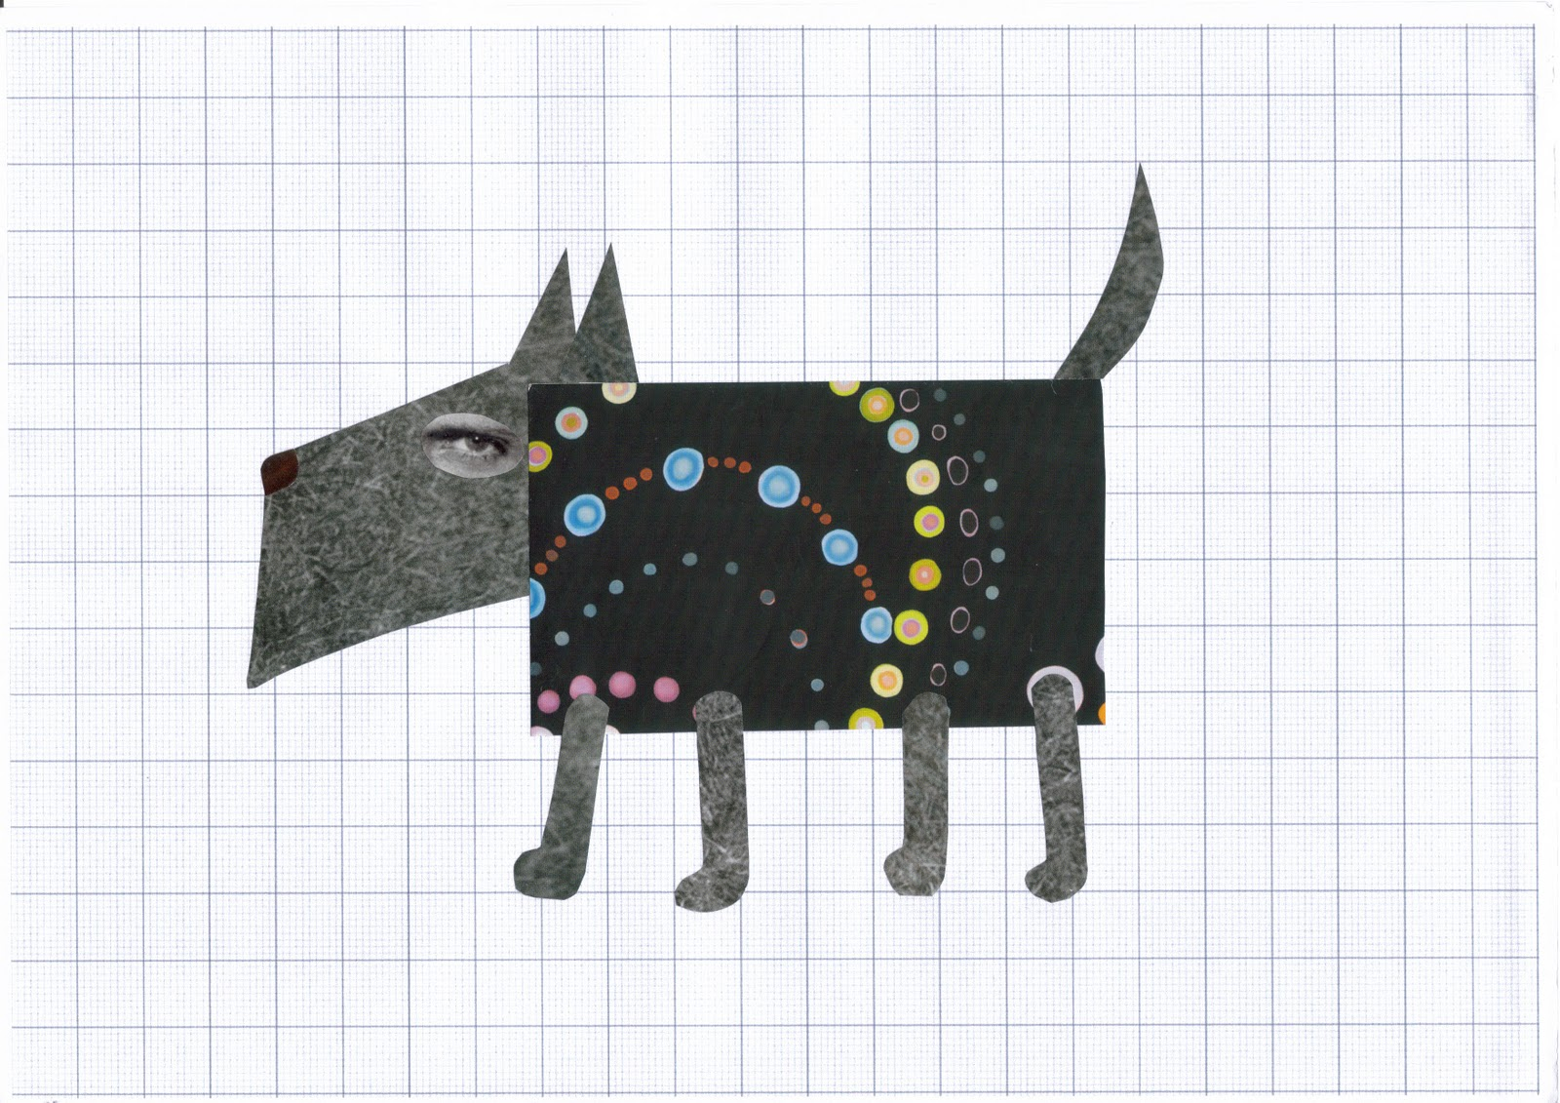](http://www.google.be/url?sa=i&rct=j&q=&esrc=s&frm=1&source=images&cd=&cad=rja&docid=GR9yn9HqYRLaeM&tbnid=f5ZDLcFm5CAY_M:&ved=0CAUQjRw&url=http://amanda--walker.blogspot.com/2010/04/blog-post.html&ei=GlOZUZ-aFeWq0AWFu4HABA&bvm=bv.46751780,d.bGE&psig=AFQjCNEZC5NeiQY5O0dhFMxgaB_fXQP5ow&ust=1369089060867975)

[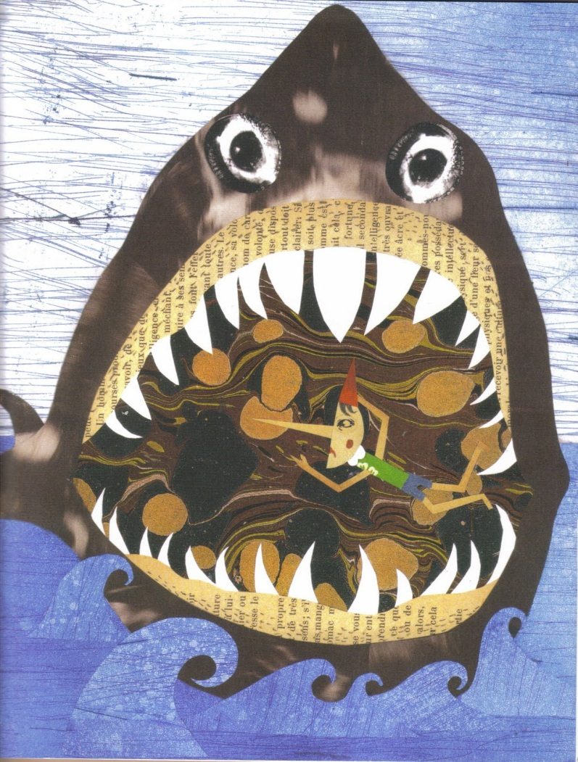](http://www.google.be/url?sa=i&rct=j&q=&esrc=s&frm=1&source=images&cd=&cad=rja&docid=GR9yn9HqYRLaeM&tbnid=pGpY2-yG3JjNrM:&ved=0CAUQjRw&url=http://amanda--walker.blogspot.com/2010/04/blog-post.html&ei=RFOZUa-FCazw0gWj4IF4&bvm=bv.46751780,d.bGE&psig=AFQjCNEZC5NeiQY5O0dhFMxgaB_fXQP5ow&ust=1369089060867975)

[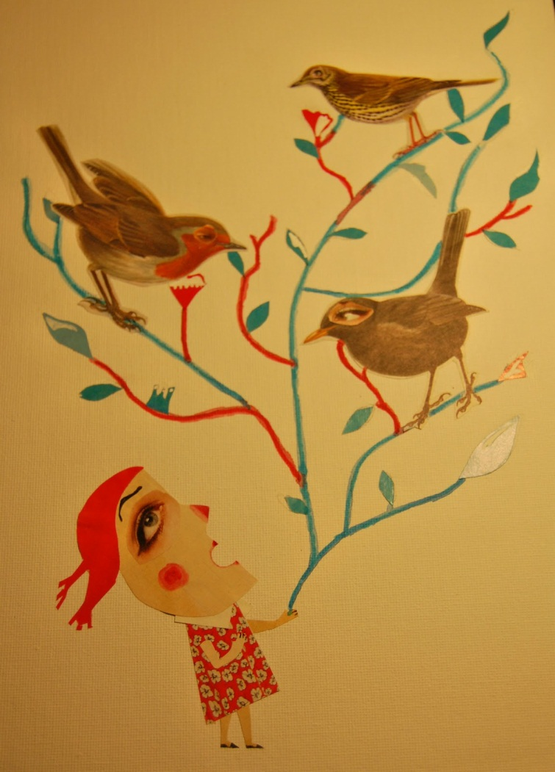](http://www.google.be/url?sa=i&rct=j&q=&esrc=s&frm=1&source=images&cd=&cad=rja&docid=KZySJwsGwSNwnM&tbnid=0TCFy1zWUA1ZIM:&ved=0CAUQjRw&url=http://marcocaruso.blogspot.com/2012/09/character-designs-sara-fanelli.html&ei=dVOZUcCpKeak0AXg44Ag&bvm=bv.46751780,d.bGE&psig=AFQjCNEZC5NeiQY5O0dhFMxgaB_fXQP5ow&ust=1369089060867975)

[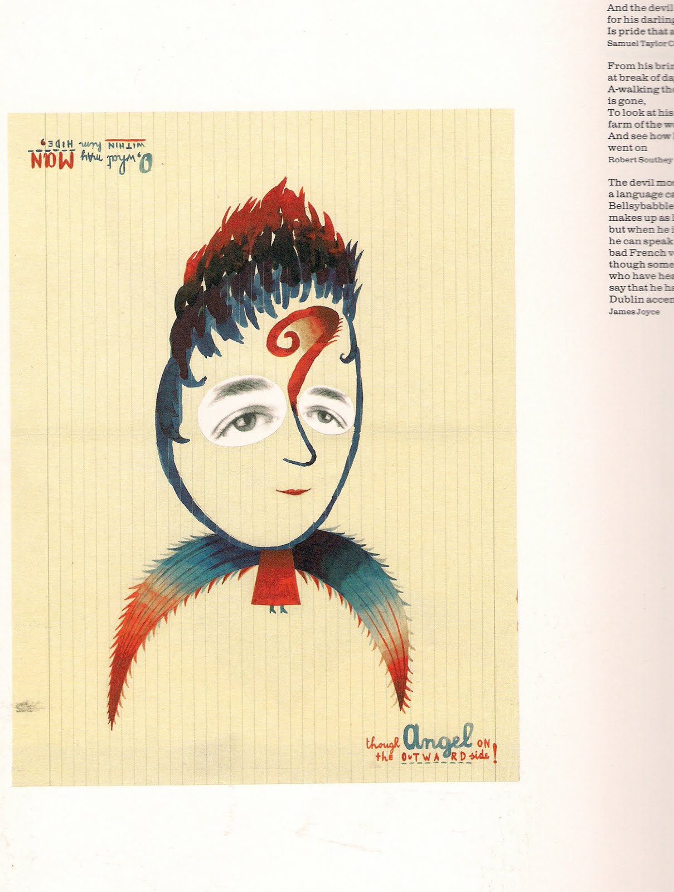](http://www.google.be/url?sa=i&rct=j&q=&esrc=s&frm=1&source=images&cd=&cad=rja&docid=hIhIOjnWhTNxVM&tbnid=bnl7gwXL7FH9YM:&ved=0CAUQjRw&url=http://weliketoresearch.blogspot.com/2010/05/sometimes-i-think-sometimes-i-am-sara.html&ei=slSZUbmbILGZ0AXfw4CYAw&bvm=bv.46751780,d.bGE&psig=AFQjCNGWbzyUacp-ETuZ9Qy1HOoKz67New&ust=1369089580846735)

[](http://www.google.be/url?sa=i&rct=j&q=&esrc=s&frm=1&source=images&cd=&cad=rja&docid=mhpjdomIJ81WKM&tbnid=73nHtt0JhpZyUM:&ved=0CAUQjRw&url=http://thecopyandpasteproject.blogspot.com/2010/06/illustration-mini-series-pt1-sara.html&ei=4NaZUavzKKfB0QX5qIGwAg&bvm=bv.46751780,d.d2k&psig=AFQjCNH0Jsbk7b45uzpj_iIetq5OGM96-g&ust=1369122904008183)

[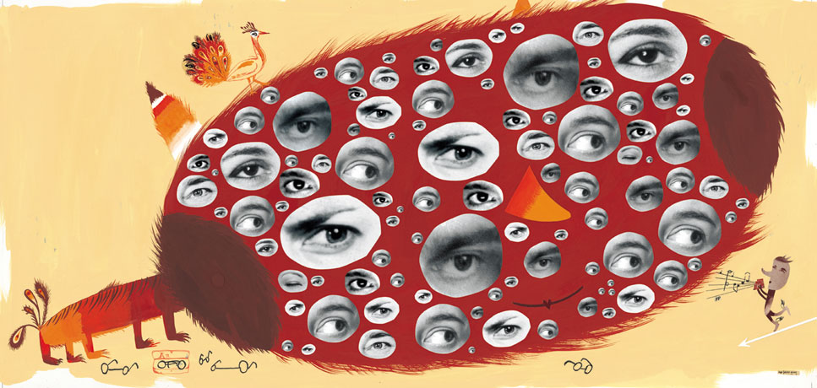](http://www.google.be/url?sa=i&rct=j&q=&esrc=s&frm=1&source=images&cd=&cad=rja&docid=WNT6YmXXn6lZyM&tbnid=swr5k97I7xB6QM:&ved=0CAUQjRw&url=http://simonsterg.wordpress.com/tag/sara-fanelli/&ei=GdeZUaiTHrHL0AXczYCgAw&bvm=bv.46751780,d.d2k&psig=AFQjCNH0Jsbk7b45uzpj_iIetq5OGM96-g&ust=1369122904008183)

[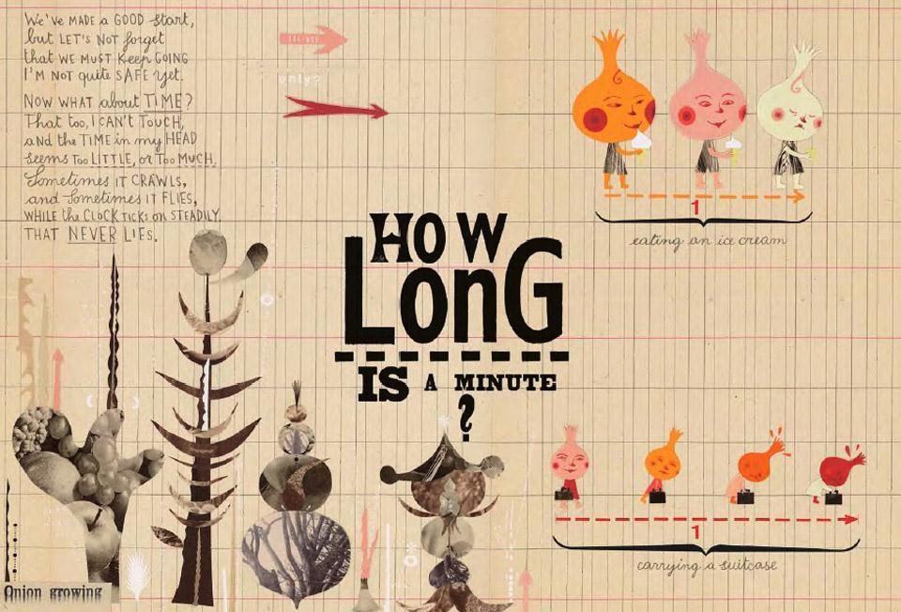](http://www.google.be/url?sa=i&rct=j&q=&esrc=s&frm=1&source=images&cd=&cad=rja&docid=RdOWbgwOtyRplM&tbnid=cTgsUC14ExdiBM:&ved=0CAUQjRw&url=http://www.booktopia.com.au/the-onion-s-great-escape-sara-fanelli/prod9780714857039.html&ei=adeZUYm0JabP0QX5lIDYBw&bvm=bv.46751780,d.d2k&psig=AFQjCNH0Jsbk7b45uzpj_iIetq5OGM96-g&ust=1369122904008183)

[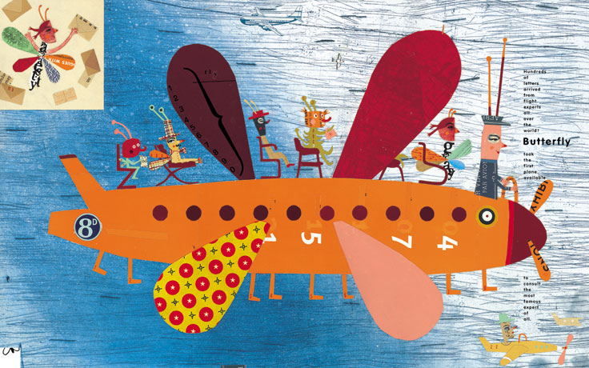](http://www.google.be/url?sa=i&rct=j&q=&esrc=s&frm=1&source=images&cd=&cad=rja&docid=ZE2n4iUR6DIPjM&tbnid=hPOdKFpKBQ1HnM:&ved=0CAUQjRw&url=http://theanimalarium.blogspot.com/2010/08/sunday-safari-travel-time.html&ei=ENmZUa3nEYbR0QXq3oCoDQ&bvm=bv.46751780,d.d2k&psig=AFQjCNH0Jsbk7b45uzpj_iIetq5OGM96-g&ust=1369122904008183)

[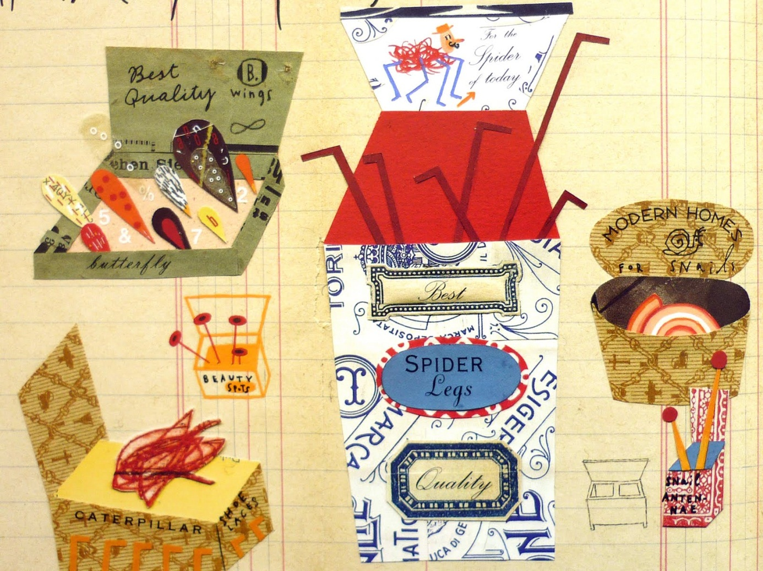](http://www.google.be/url?sa=i&rct=j&q=&esrc=s&frm=1&source=images&cd=&cad=rja&docid=Pm8fMLRHmAcMHM&tbnid=fNVmQn9slqjyUM:&ved=0CAUQjRw&url=http://absyear9art.blogspot.com/2010/11/critical-studies-collage-illustration.html&ei=MNiZUdruLYbA0QWI-YDwBg&bvm=bv.46751780,d.d2k&psig=AFQjCNH0Jsbk7b45uzpj_iIetq5OGM96-g&ust=1369122904008183)

[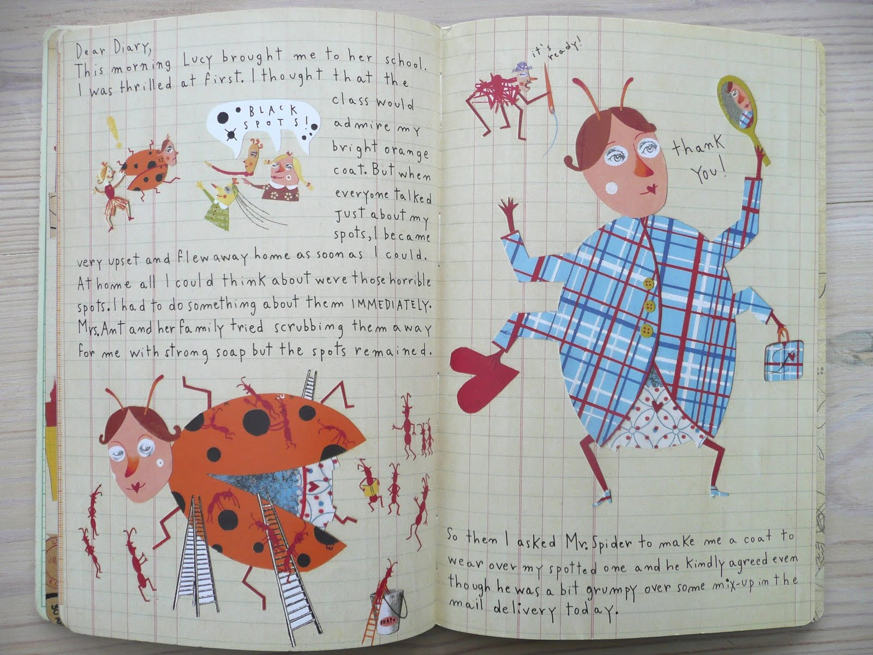](http://www.google.be/url?sa=i&rct=j&q=&esrc=s&frm=1&source=images&cd=&cad=rja&docid=mq6YHYiwgWwKbM&tbnid=u8aRVHFvQioY1M:&ved=0CAUQjRw&url=http://stickersandstuff.blogspot.com/2011/02/dear-diary-sara-fanelli.html&ei=htiZUZuoGqzw0gWj4IF4&bvm=bv.46751780,d.d2k&psig=AFQjCNH0Jsbk7b45uzpj_iIetq5OGM96-g&ust=1369122904008183)

[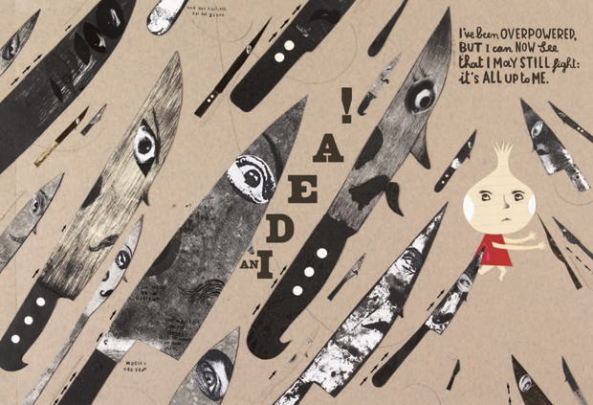](http://www.google.be/url?sa=i&rct=j&q=&esrc=s&frm=1&source=images&cd=&cad=rja&docid=bZ6YKIbv-DyKZM&tbnid=sL-6x6YiPiOTeM:&ved=0CAUQjRw&url=http://www.phaidon.com/agenda/design/articles/2012/april/02/the-thought-provoking-illustrations-of-sara-fanelli/&ei=2uKZUdzbBZGZ0QW51IDQBA&bvm=bv.46751780,d.d2k&psig=AFQjCNGqGPKOrC3KTKiJaYz6Z8OgwHuk1g&ust=1369125961842524)

[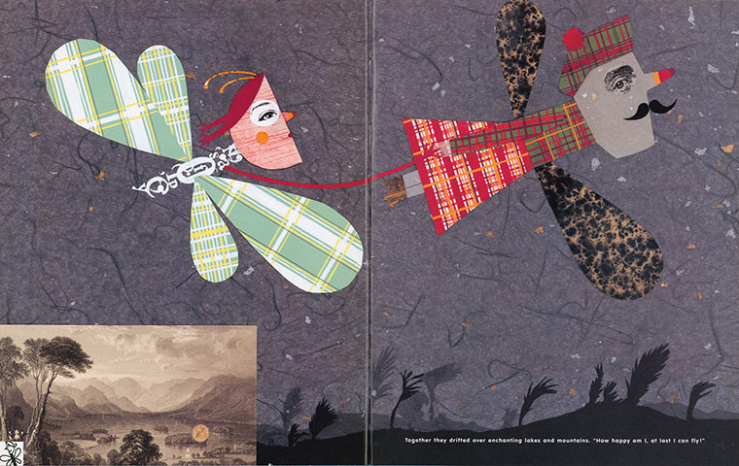](http://www.google.be/url?sa=i&rct=j&q=&esrc=s&frm=1&source=images&cd=&cad=rja&docid=ZDgu2RKUxoaf8M&tbnid=8mzfl2vKdw0wPM:&ved=0CAUQjRw&url=http://shelleysdavies.com/?p=7336&ei=k-OZUe_qAsLO0QWttIEI&bvm=bv.46751780,d.d2k&psig=AFQjCNGqGPKOrC3KTKiJaYz6Z8OgwHuk1g&ust=1369125961842524)[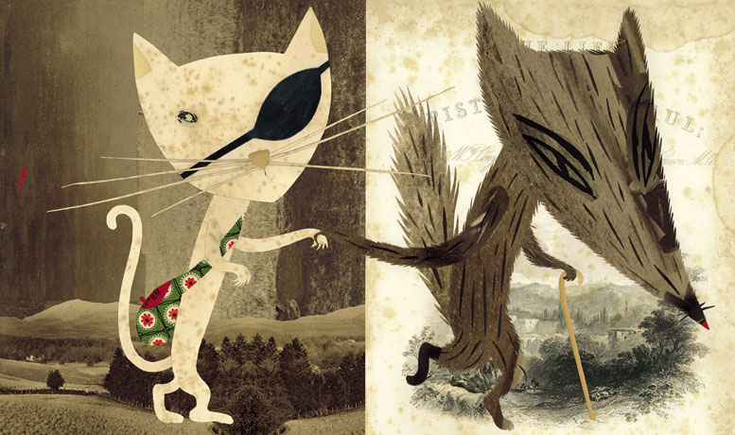](http://www.google.be/url?sa=i&rct=j&q=&esrc=s&frm=1&source=images&cd=&cad=rja&docid=zLfYdZ4-TQ3G8M&tbnid=GlEgnD2eUcZXlM:&ved=0CAUQjRw&url=http://rebeccahadfield.blogspot.com/2011/01/james-and-giant-peach-book-cover.html&ei=DeOZUe-dMMeI0AXfp4GQAg&bvm=bv.46751780,d.d2k&psig=AFQjCNGqGPKOrC3KTKiJaYz6Z8OgwHuk1g&ust=1369125961842524)

  